TABELA VERDADE DE:

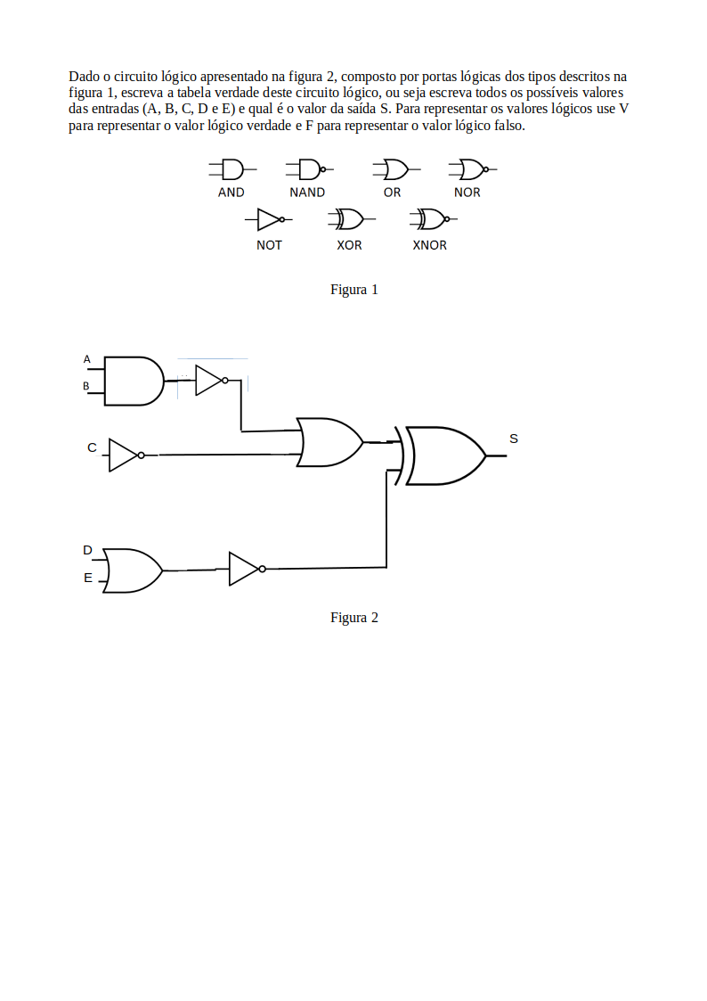

|  |  |  |  |  |  |  |  |  |  |  |  |
| --- | --- | --- | --- | --- | --- | --- | --- | --- | --- | --- | --- |
| A | B | C | D | E | A ^ B | D v E | ~(A^B) | ~C | ~(DvE) | ~(A^B) v ~C | (~(A^B) v ~C) v ~(D v E) |
| V | V | V | V | F | V | V | F | F | F | F | F |
| V | V | V | F | V | V | V | F | F | F | F | F |
| V | V | F | V | V | V | V | F | V | F | V | V |
| V | V | F | F | F | V | F | F | V | V | V | F |
| V | F | V | V | F | F | V | V | F | F | V | V |
| V | F | V | F | V | F | V | V | F | F | V | V |
| V | F | F | V | V | F | V | V | V | F | V | V |
| V | F | F | F | F | F | F | V | V | V | V | F |
| F | V | V | V | V | F | V | V | F | F | V | V |
| F | V | V | F | F | F | F | V | F | V | V | F |
| F | V | F | V | F | F | V | V | V | F | V | V |
| F | V | F | F | V | F | V | V | V | F | V | V |
| F | F | V | V | V | F | V | V | F | F | V | V |
| F | F | V | F | F | F | F | V | F | V | V | F |
| F | F | F | V | F | F | V | V | V | F | V | V |
| F | F | F | F | F | F | F | V | V | V | V | F |

ALUNO: Bruno Carvalho Caxias / 20211BSI0119